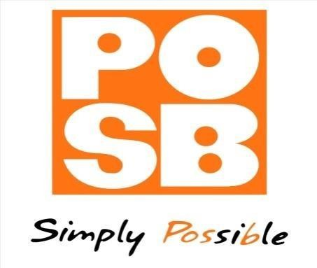

Milestone Report

IntelliRevenue Project

19 March 2026



Milestone | Percentage | Description | Planned Date | Status | Client Signature | Date
Business Requirements Sign-off | 10% | Completion and sign-off of business requirements | 6 March 2026 | Achieved
System Installation (Base System) | 20% | Base system installed and development environment ready | 9 March 2026 | Achieved
Implementation Completion | 30% | Development and configuration completed |  | Not Achieved
UAT / Go-Live | 40% | User Acceptance Testing completed and system live |  | Not Achieved

Signoff
Name | Role | Signature | Date
 | POSB Project Manager
Alvin Matewa | Simboti Project Manager |  | 19 March 2026

